ARTICLE TEMPLATE
Business Inform Journal · ISSN 2222-4459 (print) · ISSN 2311-116X (online) · www.business-inform.net

⚠ IMPORTANT: This is a template. Replace all grey italic text with your own content.
⚠ Submit your article to: biz_inf@ukr.net · Length: from 15 pages (Times New Roman 14, spacing 1.5, margins 2 cm).
⚠ Articles are accepted in Ukrainian or English.
⚠ Before submission check: UDC ✓ JEL ✓ Abstract ≥1800 characters ✓ References ≥ 15 ✓ ORCID
1. ARTICLE IDENTIFIERS

UDC | E.g.: 330.34 | JEL Classification | E.g.: O11; G21
2. ARTICLE TITLE
Enter article title here
The title should be clear, informative, and contain keywords.

Funding note (if applicable): *) This research was supported by [name of organisation / grant No. ...]
3. AUTHOR INFORMATION
📌 Complete a separate block for each author. For additional authors, copy the table below.
📌 ORCID iD is mandatory.
📌 Surname and name in English - in accordance with до ORCID iD

AUTHOR 1 (corresponding author markeded with * )
Full name | Ivanenko Ivan I. ← as per passport / ORCID
Academic degree / title | Dr of Economics, Prof. / PhD in Economics, Assoc. Prof.
Position | Professor / Research Fellow
Institution / organisation | Title institution, postcode, city, country
ORCID iD ⚠ mandatory | https://orcid.org/0000-0000-0000-0000
Email (will be published) | smith@university.edu

AUTHOR 2 (if available) …
4. ARTICLE TEXT

⚠ Text formatting: Times New Roman 14pt, spacing 1.5, margins 2 cm on all sides.
⚠ Minimum length text article including the reference list (excl. abstract і references): 15 pages.
⚠ In-text reference: [1], [2–5], [1; 3; 7]. На every source - at least once reference в text.
Introduction.
Substantiate relevance research. Formulate the research problem..
Literature Review.
Provide a thorough and critical analysis of current scholarly sources on the research topic. Identify the key approaches, concepts and findings of prior works that form the theoretical foundation of the study (with references to relevant authors and sources). Pay particular attention to contradictions, limitations and unresolved aspects of the problem. Clearly define the research gap that this study aims to fill.
Aim та methods research.
Clearly state the research aim and/or hypotheses and research questions. Identify and justify the methods and approaches used in the research. methods, approaches and software used. Clearly describe how the information base was formed andа excl.а research, data sampling parameters for analysis (if це applicable) та т.ін..
Research Results.
Present the main research results in a logically structured form. Clearly formulate the findings and substantiate them using appropriate analytical methods. The analysis of indicators/phenomena studied should be accompanied by references to tables and figures (Table, Fig.) illustrating the results. Ensure consistency between the text and the graphic and tabular materials presented. All tables and figures must include a Source note and be provided in an editable format. Interpret the results by explaining their economic meaning and significance. Where possible, compare your results with findings of other researchers, indicating consistency or differences (with appropriate references).
Discussion.
⚠ Discussion may be combined with Conclusions.

Discuss whether theresults confirm / refute / complement the conclusions prior studies researchersв [author, year] [reference] regarding [topic]. Demonstrate the original scholarly contribution to addressing the problem. Identify the limitations of the study. presented research.
Conclusions.
Clearly formulate conclusions of the study. Substantiate the scientific novelty and practical significance of the results. Formulate пractical recommendations stakeholders, policymakers and other target groups. Indicate promising directions for further pіresearch.и further studies analysed problem.
GUIDELINES FOR FORMATTING TABLES

⚠ Title Table - ABOVE Table, in centre.
⚠ Numbering is continuous по throughout the entire article: Table 1, Table 2 …
⚠ Source - BELOW Table, left-aligned or по centre, in italics: Source: compiled by the authors / on the basis of [source].
⚠ In the body of the article - in-text reference is mandatory: (Table 1) or «… presented в Table. 1».
⚠ Table must not exceed the page margins. Wide tables may be placed in landscape orientation. ced in landscape orientation.
⚠ If a table continues on the next page, - repeat the header row and add “Table 1 continued”.
⚠ Abbreviations в Table should be explained in a note below: Note: … ; * - …
⚠ Tables may use a minimum of 12 pt font with single line spacing.

Example.
In-text reference: … key performance indicators of the enterprise are presented in Table 1.
Table 1
Key production and economic performance indicators of the enterprise, 2022-–2023
Indicator | 2022 | 2023
Output volume, UAH million | 1 245.3 | 1 418.7
Growth rate, % | – | 113.9
Number of employees, person | 342 | 361
Source: compiled by the authors based on the financial statements of the enterprise [9]
GUIDELINES FOR FORMATTING FIGURES

⚠ Figures are centred on the page and must not exceed the margins.
⚠ Numbering: Fig. 1, Fig. 2 … - continuous по throughout the entire article.
⚠ Caption - BELOW the figure, centred, in italics: Fig. 1. Figure title.
⚠ Source - one line below the caption, in italics: Source: compiled by the authors / based on [source]
⚠ In the body of the article - in-text reference is mandatory: (Fig. 1) or “… as shown in Fig. 1”
⚠ Figures must be editable or saved at a resolution of ≥ 300 dpi.
⚠ Chart axes must be labelled with units of measurement.
⚠ All text within figures - Times New Roman or Arial, minimum 8pt.
⚠ Colour figures are permitted. Ensure, що Fig legible і у black and white.
Example
In-text reference: … the dynamicsу of the indices presented на на Fig. 1.
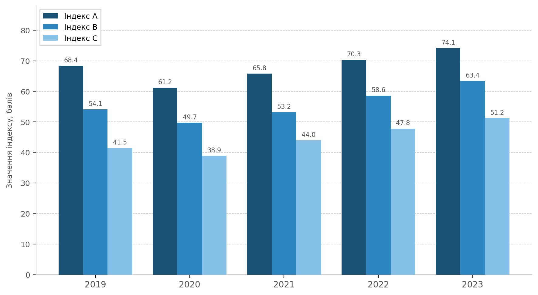
Index value, points
Years
Fig. 1. Dynamics of Competitiveness Indices of Industry Enterprises, 2019-2023, points
Source: compiled by the authors based on data from the State Statistics Service of Ukraine [6]
5. REFERENCES

⚠ Minimum 15 sources. Preference should be given to publications in indexed journals.
⚠ Formatting - in accordance with DSTU 8302:2015. Every listed source - at least once reference в text.
⚠ Self-citation should be kept to a minimum (не more than 15% of the total number of sources).
⚠ Always include DOI where available. Verify all links to internet resources.

Formatting examples in accordance with DSTU 8302:2015:
Monograph:
1. Petrenko V. I. Title of Monograph. Kyiv : Publisher, 2023. 256 p.
Journal article (with DOI):
2. Ivanenko I. I., Kovalenko O. P. Article title. Business Inform. 2024. No. 3. P. 45–52. DOI: https://doi.org/10.XXXX/XXXX
Journal article (English-language):
3. Smith J., Brown A. Article title. Journal Name. 2023. Vol. 15. No. 2. P. 100–115. DOI: https://doi.org/10.XXXX/XXXX
Conference proceedings:
4. Sydorenko M. V. Report title. // «Title» : мIn: “Title” : Proceedings of the International Scientific-Practical Conference М(Kharkiv, 13 December). Kharkiv, 2024. С. 34–37.
Online resource:
5. Title of material. Resource name. URL: https://www.example.com/page (accessed: DD.MM.YYYY).

6. AUTHOR DECLARATIONS

Funding | This research received no external funding / This research was supported by [name of organisation, grant No. ...]
Conflict of interest | The authors declare no conflict of interest / [Description of conflict of interest, if є]
Use of AI | No AI tools were used in the preparation of this work / The authors used [tool name / version] for the purpose of [aim]. The authors reviewed and edited the content generated.
Originality | The submitted material has not been previously published and has not been submitted to any other journal.
7. ABSTRACT AND KEYWORDS
⚠ Minimum length of the abstract length: 1,800 characters including spaces.
⚠ Abstract та keywords submitted in UKRAINIAN and ENGLISH .
⚠ Abstract structure: relevance → aim → methods → results → conclusions / scholarly novelty.

Surnames and initials of all authors in Ukrainian. Article title in Ukrainian.
Relevance problem … [Briefly justify]. The aim of the article is to … [State aim research]. Methods used: [[Briefly describe methods, approaches, statistical basis]. The study examines [what was studied]. The results of the research show [key results]. It is established that, що [main conclusions]. It is proved / substantiated that [scholarly novelty]. Recommendations are proposed [practical recommendations].
Keywords: keyword 1; keyword 2; key phrase 3; keyword 4; keyword 5.
Minimum 3, maximum 8 keywords or key phrases

Submit the article file and completed Author Information Form to:
biz_inf@ukr.net
Contact: Telegram / Viber +38-066-240-82-97

